Code Printout:

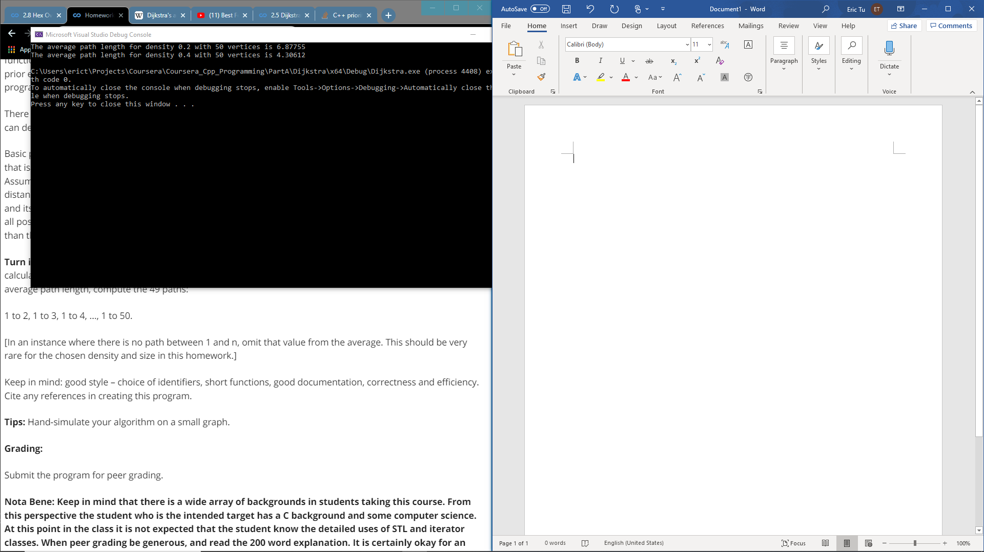

I learned that a priority queue heap sorts during function execution and does not appear as sorted when debugging through the IDE. I also learned the details of implementing Dijkstra, that there is a need to keep track of the last index when adding path costs to the priority queue. Additionally, when there is no path between the specified nodes, dummy value or exception handles are needed to for this implementation of Dijkstra due to strong return typing constraints with c++.

(Coursera won’t let me send multiple files so copying code underneath)

Main.cpp

#include "Graph.h"

#include "ShortestPath.h"

#include "PriorityQueue.h"

#include <iostream>

#include <deque>

using namespace std;

void calcAvePath(Graph graph)

{

ShortestPath spath(graph);

double ave_path_length = 0.0;

int num_paths = 0;

for (int i = 1; i < graph.getNumVertices(); i++)

{

// Check for path

pair<deque<int>, int> out = spath.findPath(0, i);

deque<int> path = out.first;

int cost = out.second;

if (cost != 10) {

int i = 0;

}

if(path[0] != -1)

{

// Incremental average

num_paths++;

ave_path_length += (cost - ave_path_length)/num_paths;

}

}

std::cout << "The average path length for density " << graph.getDensity() <<

" with " << graph.getNumVertices() << " vertices is " << ave_path_length << std::endl;

return;

}

int main()

{

// Create graphs

int num_vertex = 50;

Graph graph20(num_vertex);

Graph graph40(num_vertex);

// Create one graph with density 0.2 and range 1-10

// Create other grpah with density 0.4 and range 1-10

graph20.createEdges(0.2, 10);

graph40.createEdges(0.4, 10);

calcAvePath(graph20);

calcAvePath(graph40);

return 0;

}

Priority Queue

#pragma once

#include <queue>

#include <vector>

#include <tuple>

using namespace std;

class PathNode

{

public:

PathNode() : m_vertex(-1), m_cost(-1), m_prev_vertex(-1) {};

PathNode(int vertex, int cost, int prev_vertex) : m_vertex(vertex), m_cost(cost), m_prev_vertex(prev_vertex) {};

int getCost() { return m_cost; };

int getVertex() { return m_vertex; };

int getPrevVertex() { return m_prev_vertex; };

private:

int m_vertex;

int m_cost;

int m_prev_vertex;

};

class Comparator

{

public:

bool operator() (PathNode& p1, PathNode& p2)

{

return (p1.getCost() > p2.getCost());

}

};

class PriorityQueue{

public:

PriorityQueue();

~PriorityQueue();

PathNode useTop();

void insert(const PathNode& p1);

void clear();

int size();

private:

priority_queue<PathNode, vector<PathNode>, Comparator> m_queue;

// key = node

// value = distance

};

#include "PriorityQueue.h"

PriorityQueue::PriorityQueue() {};

PriorityQueue::~PriorityQueue() {};

void PriorityQueue::insert(const PathNode& p1)

{

m_queue.emplace(p1);

}

PathNode PriorityQueue::useTop()

{

if (!m_queue.empty())

{

PathNode ans = m_queue.top();

m_queue.pop();

return ans;

}

throw "Empty Priority Queue";

}

int PriorityQueue::size()

{

return m_queue.size();

}

void PriorityQueue::clear()

{

m_queue = priority_queue<PathNode, vector<PathNode>, Comparator>();

return;

}

Shortest Path algo

#pragma once

#include <vector>

#include <cassert>

#include "PriorityQueue.h"

#include "Graph.h"

#include <map>

#include <deque>

using namespace std;

class ShortestPath {

public:

ShortestPath(Graph graph);

pair<deque<int>, int> findPath(int v1, int v2);

int pathSize(int v1, int v2);

private:

void addToClosedSet(PathNode node);

void addNeighborsToOpenSet(int vertex);

void reset();

int last_vertex;

// Key = Node; Value = Cost, PrevNode

map<int, pair<int, int>> m_closed_set;

PriorityQueue m_open_set;

Graph graph;

};

#include "ShortestPath.h"

ShortestPath::ShortestPath(Graph graph) : graph(graph)

{

m_open_set = PriorityQueue();

}

pair<deque<int>, int> ShortestPath::findPath(int v1, int v2)

{

reset();

assert(v1 < graph.getNumVertices());

assert(v2 < graph.getNumVertices());

last_vertex = v1;

// Put origin in closed set

addToClosedSet(PathNode(last_vertex, 0, -1));

PathNode next_node;

while (true)

{

// Put neighbors in open set

addNeighborsToOpenSet(last_vertex);

// Bring in smallest open set cost to closed set

// In format (vertex, edge)

// If destination, stop

if (m_open_set.size())

{

next_node = m_open_set.useTop();

}

else

{

// Path does not exist, return -1 shortest_path and Infinite cost

deque<int> shortest_path;

shortest_path.emplace_back(-1);

int shortest_cost = std::numeric_limits<int>::max();

return pair<deque<int>, int>(shortest_path, shortest_cost);

}

if (next_node.getVertex() == v2)

{

// Find shortest cost by referencing closed set

addToClosedSet(next_node);

int shortest_cost = m_closed_set.find(last_vertex)->second.first;

// Trace previous nodes recorded to find shortest path

deque<int> shortest_path;

int vert = v2;

shortest_path.push_back(vert);

while (vert != v1)

{

int prev_vertex = m_closed_set.find(vert)->second.second;

shortest_path.push_front(prev_vertex);

vert = prev_vertex;

}

return pair<deque<int>, int>(shortest_path, shortest_cost);

}

else if (m_closed_set.find(next_node.getVertex()) == m_closed_set.end())

{

// No previous path to this node, add to closed set

addToClosedSet(next_node);

}

else

{

// Skip since shortest path already found

}

}

// Put neighbors in open set, updating values if necessary

}

void ShortestPath::addToClosedSet(PathNode next_node)

{

int next_vertex = next_node.getVertex();

int next_edge_cost = next_node.getCost();

int next_prev_vertex = next_node.getPrevVertex();

auto val = pair<int, int>(next_edge_cost, next_prev_vertex);

m_closed_set.insert(map<int, pair<int, int>>::value_type(next_vertex, val));

last_vertex = next_vertex;

}

void ShortestPath::addNeighborsToOpenSet(int vertex)

{

vector<int> nb = graph.getNeighbors(vertex);

int cur_edge = m_closed_set.find(vertex)->second.first;

for (auto v : nb)

{

if (m_closed_set.find(v) == m_closed_set.end())

{

m_open_set.insert(PathNode(v, cur_edge + graph.getEdgeValue(vertex, v), last_vertex));

}

}

}

void ShortestPath::reset()

{

m_closed_set.clear();

m_open_set.clear();

}